System Specification for

Adventures of an Adventurer

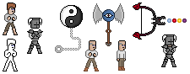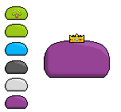

|  |  |
| --- | --- |
| Project Name | The Adventures of an Adventurer |
| Project Manager | Sascha Bertleff |
| Document Owner | Group Ferstl, Guendogan, Bertleff |
| Created on | 22.12.15 |
| Last modified | 22 December 2015, 08:14:00 |
| State | X in Work  vorgelegt  Released |
| Dokumentablage | Gruppe Ferstl, Guendogan, Bertleff System Specifications |

**Document History**

|  |  |  |  |  |  |
| --- | --- | --- | --- | --- | --- |
| Nr. | Date | Version | Chapter | Modification | Author |
| 1 | 22.12.15 | 0.1 | 1 | Creation of the Document | Sascha Bertleff |
| 2 | 19.01.16 | 0.2 | 1-3 | Creation and modification of chapter 1 to 3 | Sascha Bertleff |
| 3 | 26.01.16 | 0.3 | 1,2,3,4 | Extending of chapter 2,3 and 4 | Sascha,  Cedric,  Oguz |
| 4 | 02.02.16 | 1.0 | 1,2,3,4 | Finished Chapter 1 to 4 | Sascha,  Cedric,  Oguz |

Inhaltsverzeichnis

1. Initial Situation and Goal 4

1.1 Initial Situation 4

1.1.1 Application Domain 4

1.1.2 Glossary 4

1.2 Goal Definition 4

2. Functional Requirements 5

2.1 Use Case Diagrams 5

2.2 Explanation of the User Cases 5

3. Non-functional Requirements 7

4. Quantity Structure 7

5. System Architecture and Interfaces 7

# 1. Initial Situation and Goal

The main goal of our Project is to create a Game which people can enjoy and find funny. This happens with the humorous story or with many innuendos and game elements which are just so random, that they are amusing.

We want to keep the game simple, so that it can run on every Standard PC from nowadays.

The art style of the game is like an old SNES game. Many pixels

The compatibility with other Systems will not be a problem because the Unity-Engine runs on nearly every common operating system (For Example: Windows, Mac, and Linux). We also plan to release the Game for Wii U later on.

## 1.1 Initial Situation

Beside the clarification of the initial situation in the project proposal this game is made for the classic pixel art gamer, but honestly everyone can play it and should be have his/her fun with it. According to the game it will run on the most PC’s on Windows XP and above. After Windows the game would be playable at any Linux and MAC system. Our later goal would be to bring our game to the mobile market and develop it for Android and IOS and maybe also for Wii U. Further information will be published.

### 1.1.1 Application Domain

The game will be very simple and should not make any trouble with performance of the game or a high hardware usage. The main problem area could be the compatibility of the Unity version. Briefly said, our game should run on any PC’s which can support Unity 5.3 or above. Later in the development the game should be run on any Android device with Android 2.3 and above and any IOS device with IOS 5 and above.

### 1.1.2 Glossary

* **SNES**: Super Nintendo Entertainment System; a gaming console made by Nintendo from 1990
* **Wii U**: a gaming console made by Nintendo from 2012
* **Quest**: a task given to the player by another person, mostly to receive a reward in exchange; a journey towards a goal
* **Item**: an object that in most cases has a certain usage
* **DLC:** Download Content; exclusive downloadable extra content for the game
* **Pixel Art:** pictures or graphics that are drawn using only a short amount of pixels, like for example 16x16
* **Steam:** an Internet-based digital distribution platform developed by Valve Corporation
* **Indie Games:** video games created by individuals or small teams generally without video game publisher financial support
* **Unity:** a multiple-platform game engine and development toolkit
* **RPG:** Role-Playing Game, a game genre

## 1.2 Goal Definition

The main goal of the game is to entertain any kind of person and bring joy and fun among them. Although the main reason of a game is to have fun while playing we are trying to give the best experience of a 2D Action RPG game. The target group is simple everybody from children to older person. Mostly RGP players should have his/her fun, but everybody should have his/her fun either.

# 2. Functional Requirements

* The game should not need an up-to-date processor, graphic card or too much RAM (Sascha mach weg :C)

## 2.1 Use Case Diagrams

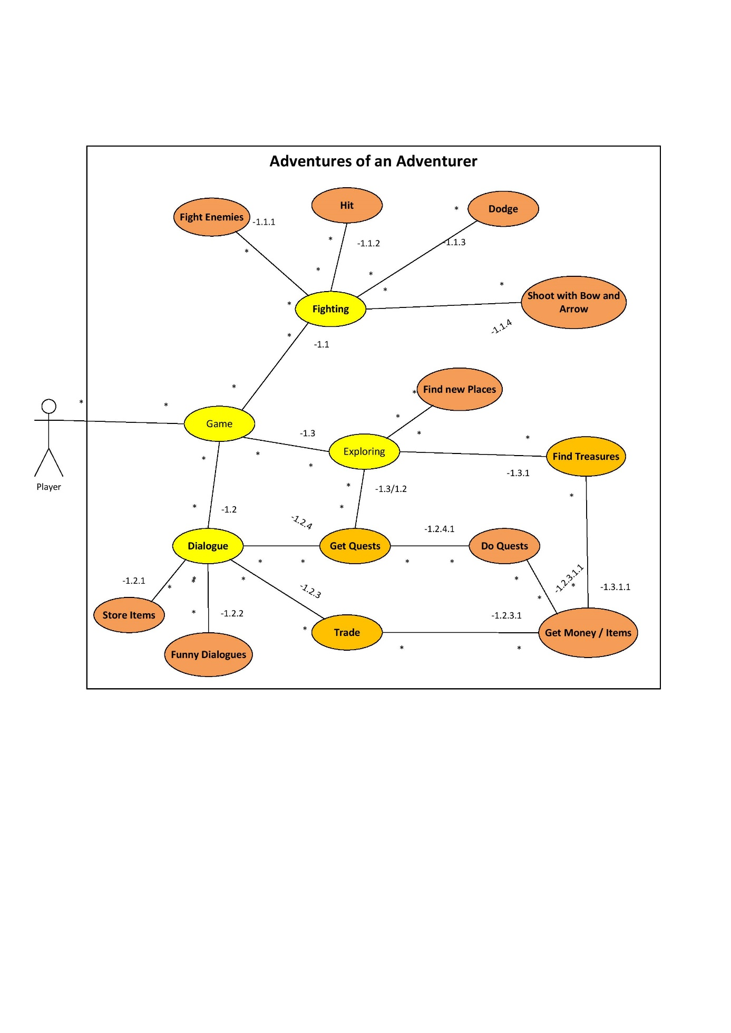

## 2.2 Explanation of the Use Cases

### Use Case: Game ID: 1

The basic Idea of the Game can be broken down in 3 Main User Cases **Fighting**, **Exploring** and **Dialogue.**

### Use Case: Fighting ID: 1.1

The fighting user Case describes our combat system. The System is kept very simple so that everyone can understand it. The user Case includes four basic methods of fighting: **shot with a Bow and arrow**, **Dodge**, **Hit** and of course **the** **enemy one fights against**.

### Use Case: Fight Enemies ID: 1.1.1

This User Case simply describes that one only fights against enemies and not allied people. For example if the Adventurer has to do a Quest he does not slay every single man and creature in his way, only the people who are a threat to him or needed to be killed for a quest.

### Use Case: Hit ID: 1.1.2

This User Case describes that the player can be hit by an Enemy and take damage.

### Use Case: Dodge ID: 1.1.3

In order to avoid getting damaged the player has also the option to dodge an attack of the enemy with a button press. Of course the movement has a cool down.

### Use Case: Shot with Bow and Arrow ID: 1.1.4

The player can also use a bow to fight against enemies. The bow is one of the many items which can be bought at a shop or found by the player.

### Use Case: Dialogue ID: 1.2

This Use Case connects the different ways one can interact with people and the results which accrue from it. This can be: that the player can store items, simply speak to people and get funny dialogs, trade or get Quests.

### Use Case: Store Items ID: 1.2.1

One can store items by interacting with the people who are in the storehouse (there will be a storehouse in every town) in this storehouse the player can store the items he does not need any more or can’t carry.

### Use Case: Funny Dialogs ID: 1.2.2

The player can also talk to the people and get funny dialogues.

### Use Case: Trade ID: 1.2.3

One can talk to a person (e.g.: a Trader) to sell or buy Items.

### Use Case: Get Quest ID: 1.2.4

This Use Case describes, that the player can get a Quest either by talking to someone or by finding one trough exploring (e.g.: finding an mysterious treasure map).

### Use Case: Get Money/items ID: 1.2.3.1, 1.2.3.1.1, 1.3.1.1

A player can get money either by trading some items, doing a Quest or finding money like treasures. The same can be said for items.

### Use Case: Exploring ID: 1.3

The player has the opportunity to explore the world. **Find new Places**, **Find Treasures** or **Get Quests**.

### Use Case: Find new Places

One can find new places by exploring the world. This places can be a new city or a cave which the player can explore.

### Use Case: Find Treasures ID: 1.3.1

This Use Case represents that while the player is exploring he can find valuable items (e.g.: a new sword, a valuable golden statue…), Gold or just random Stuff (Crafting Stuff like ingots, lather, magic crystals…). The items one finds will be dynamically. For Example ingots can be found mainly in mines or lather in the nature or in an abandoned cabin in the woods.

# 3. Non-functional Requirements

* USE:
  + easy to understand controls
  + game should be playable in German and in English
  + not too complex story
  + clear and uncomplicated dialogues
* EFFIC:
  + fast runtime for smooth gameplay
  + short loading times
  + low memory usage through use of pixel art
* MAINT:
  + maybe there will be a Wii U version later on
  + also we’ll possibly be making one or more DLC’s
  + future release on Steam
* SEC:
  + encryption for the data in the save files
  + source code won’t be included in the user version
  + source code could be offered separately for modders for example
* LEGAL:
  + age requirement will eventually be defined by the uploading site itself
  + other than that there are no law requirements

# 4. Quantity Structure (Schätzung Größe)

The one of the most important steps on our project is, to guarantee a smooth run of the game and the low use of memory. In the following tests you will get a briefly overview of the game architecture and the specs it needs. Since this is a simple game it won’t need any databases and the saves will be saved into a .txt file and will be reading at any loading process. Also the configurable settings of the game will be saved into a .txt file and can be changed at any time.

# 

# 5. System Architecture and Interfaces

This game is made with Unity 5.3 and usual for indie/pixel games it doesn’t need any high end PC to run this game smoothly.

Easy saying the game can be played smoothly on every PC that does not have a lesser Windows version of Windows XP. It can also run on many IOS Systems or Linux Systems. In the near future the game will be also available on the Wii U.

Here are the specs:

|  |  |
| --- | --- |
| OS | Windows XP and above, any IOS System which supports Unity, any Linux System which supports Unity |
| CPU | Any CPU which can run Unity 5.3 or above |
| RAM | 1 GB Ram |
| Graphic card | Any Graphic Card which can run Unity 5.3 or above |
| DirectX | DirectX 9 or above |
| Sound | DirectX compatible Soundcards |

Acceptance Criteria

Open Points

GUI’s (Bild)

# 6. Acceptance Criteria